LGE Internal Use Only

LGE VS [OEM NAME] [PROJECT NAME]

Software Integration Test Plan (SWITP)

About This Template
- Template Name: LGE_VS_SWIT_T01_SWITP(Software Integration Test Plan)
- Management Department: VS SW Process Team
- Revision History
Version | Date | Comment | Author
2.0 | 2017-10-16 | Initial Release  - Modified from LGE_VC_Template_TMP(Test_Master Plan_v1.0 to comply with A-SPICE 3.0 and ISO 29119 | VC Smart SW Process Team  LG Electroincis
2.1 | 2019-03-08 | Update due to annual organization restructuring (VC --> VS) | VS Smart SW Process Team
2.2 | 2021-08-06 | Updated term below;  3.5.2 Test Case Conformity Review ->  Test Case Verification Review | VS Smart SW Process Unit
2.2 | 2021-08-06 | Updated security notice of this template (Before: LGE Confidential->After: LGE Internal Use Only).  Security level related note (the last sentence in red color below) | VS Smart SW Process Unit

Read me first
- This template is a basic form for the Software Integration Test Plan document, consisting of a preparation guideline (geen box) and an example.
- Read and understand the contents of General Guidelines before writing a document.
- Delete all preparation guidelines (green boxes) after completing the document.
- Since the content composition of this template may not fit 100% of all projects, tailoring should be used to suit the size and characteristics of the project.
- Use the term Item in the test area with regard to terms.
That is, the terms Element, Component of the development phase are not used.
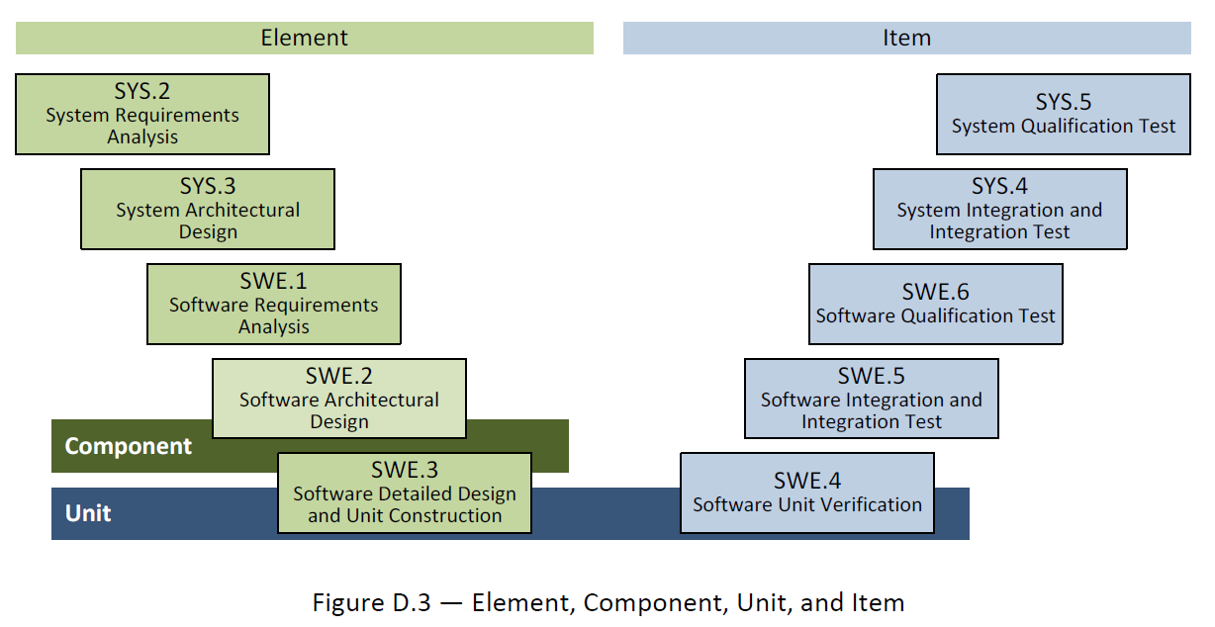
- The notice “LGE Internal Use Only” is for this template itself. The document which use this template needs to be classified as suitable security level according to its content.

General Guidelines
- Ground Rules for SWITP
- This Test Plan for each test area is to validate each development area.
That is, the targets and criteria for testing areas are planned based on the corresponding development areas.
- TMP is tailoring in consultation with concerned staff according to project status.
- Seven Rules
- Write from the reader's point of view..
- Avoid unnecessary repetition of information in the document.
- Make sure there is no ambiguity in the document. Clearly specify the meaning of the notation used in the diagram.
- Use the standard structure of the document. Create an easy-to-reference structure. Don't leave the blank for difficult parts and mark them "to be metered."
- Record the reasons for adopting the test. It is useful for future reviews or changes.
- Do not reflect the changes immediately on the document. Instead, reflect the changes according to the document's version control and release schedule.
- Ask the target reader for a review.
- References
This template has been revised by referring to the following test related technical data and the TMP template and guide document which have been distributed in the past.
- Automotive_SPICE_PAM_v3.0
- ISO/IEC/IEEE 29119 Software Testing Standard
- ISO/IEC/IEEE 25010:2011 Systems and Software Engineering
- Previously deployed TMP templates and guidelines from VS
- Document Format
If you use this template, you don't have to worry about document forms. Follow the basic rules below.
- Body font : Clear Gothic
- Give numbers and titles to all pictures and tables and make them easy to mention.
- Automatically insert captions : Select a figure or table from [Reference] > [Captition In] > [Label] in woad and select OK.
- Caption location :
Insert caption below picture : Figure 1 picture titl, Figure 2 picture titl, ..
Insert captions over table : Table 1 table title, Table 2 table title, ..
- Document Versioning, File Naming Rule
See the section 'Naming Rules for Document Output' in the Configuration Management Guideline (LGE_VS_Guideline_Form Management) managed within a project.
About This Document
Document Information
Issuing authority | VS OOO Team
Configuration ID | Configuration Item ID of CMBook
Status of document | In Progress / Approved / Released

Revision History
Write revision history.
Make sure that the latest contents are at the top.

Verion | Date | Comment | Author | Approver
#.# | YYYY-MM-DD | OOOOOOO | OOO | OOO

Purpose
Write about the purpose of this document.
This document is a test plan for the [Project Name].

Scope
Write about the scope of this document.
This document includes the following.
- Test strategy
- Test Scope
- Quality objectives
- Roles and Responsibilities
- Test methodology
- Test schedule
- Test output
- Measurement
- Regression test
- Test criteria
- Test environment
- Test constraints
- Test risk

Audience
Write a person to read this document.
The target audience for this document is as follows :
- Project Manager
- Project Leader
- Project Sub-leader
- SW Engineer
- HW Engineer
- Test Engineer
- Configuration Manager
- Requirement Manager

Related Documents
Write documentation related to the use of this document.
The documents related to this document are as follows :
- LGE_[OEM]_[Project name]_TMP
- LGE_[OEM]_[Project name]_SWUTP
- LGE_[OEM]_[Project name]_SWITP
- LGE_[OEM]_[Project name]_SWTP
- LGE_[OEM]_[Project name]_SysITP
- LGE_[OEM]_[Project name]_SysTP
- LGE_[OEM]_[Project name]_SWUTC
- LGE_[OEM]_[Project name]_SWITC
- LGE_[OEM]_[Project name]_SWTC
- LGE_[OEM]_[Project name]_SysITC
- LGE_[OEM]_[Project name]_SysTC
- LGE_[OEM]_[Project name]_PMP
- LGE_[OEM]_[Project name]_CMP
- LGE_[OEM]_[Project name]_CMBook
- LGE_[OEM]_[Project name]_WBS
- LGE_[OEM]_[Project name]_PRM

Conventions and Acronyms
Conventions
In this document, easy-to-know notes and important things you should know are as follows.

NOTE
A number of useful notes to keep in mind in text

CAUTION
Important items must to know

Acronyms

Acronym | Description
TMP | Test Master Plan
SysTP | System Qualification Test Plan
SysT | System Qualification Test
SysITP | System Integration Test Plan
SysIT | System Integration Test
SWTP | Software Qualification Test Plan
SWT | Software Qualification Test
SWITP | Software Integration Test Plan
SWIT | Software Integration Test
SWUTP | Software Unit VerficiationPlan

Table of Contents
1 Plan Context 1-1
1.1 Test Item 1-1
1.2 Test Scope 1-1
1.3 Functionality 1-1
1.4 Non-Functional Quality Attributes 1-1
2 Risk Register 2-3
2.1 Project Risks 2-3
2.2 Product Risks 2-3
3 Test Strategy 3-5
3.1 Integration Strategy 3-6
3.2 Integration Test Strategy 3-6
3.3 Test Process 3-6
3.4 Test Deliverables 3-6
3.4.1 Test Cases 3-6
3.4.2 Test Results Report 3-7
3.4.3 Test Plan 3-7
3.5 Reviews 3-7
3.5.1 Testability Review 3-7
3.5.2 Test Case Verification Review 3-8
3.6 Test Design Techniques 3-8
3.6.1 Interface Testing 3-8
3.6.2 Specification Based Testing 3-8
3.6.2.1 Scenario Testing (example) 3-9
3.6.3 Structure Based Testing 3-9
3.6.4 Experience Based Testing 3-10
3.7 Test Entry/Completion Criteria 3-10
3.7.1 Entry Criteria 3-10
3.7.2 Completion Criteria 3-10
3.8 Metrics to be collected 3-11
3.8.1 The Metrics of Measurement Analsysis 3-11
3.8.1.1 SW Interface Coverage (example) 3-11
3.8.2 The Metrics of Test Cases Develoment Plan 3-11
3.9 Retesting and Regression Testing 3-11
3.10 Test Data 3-12
3.11 Test Environment Requirements 3-12
3.11.1 Test Tools 3-12
3.11.1.1 SW Testing Tools 3-12
3.12 Suspension and Resumption Criteria 3-12
4 Schedule 4-14

Figures
Figure 1 Bidirectional Traceability and Consistency of A-SPICE PAM 3.0 3-5
Figure 2 Test Process 3-6
Figure 3 Requirement Testability Review 3-8
Figure 4 Workflow 4-14

Tables
Table 3-4 Entry Criteria 3-10

Plan Context

Test Item
Describe the outline of the Software Integration Test Item.
Visualize by inserting relevant Collab Link information.

Test Scope
The software integration area developed by LG is defined as Test Scope and explained.

Functionality
Write a function list with the Lv.1 level of the FRP(Feature Release Plan) document.

Table 1 Features
Feature | Description

Non-Functional Quality Attributes
Write in accordance with ISO/IEC 25010 Description and Guideline.

Table 2 Quality Attributes
Main characteristic | Sub characteristic
Functional suitability
Performance Efficiency
Compatibility
Availability (Usability)
Reliability
Security
Maintenance (Maintainability)
Mobility (portability)

Risk Register
The risk associated with the test should be derived from the predefined risk in the project.
If there is no definition, do not write it as optional.

Project Risks
※ Risk = Likelihood × Impact
※ Likelihood: 1 (Low), 2 (Medium), 3 (High) / Impact: 1 (Low), 2 (Medium), 3 (High)

Table 3 Risks
ID | Project Risk | Likelihood | Impact | Risk Score | Mitigation Activities
P1 | Lack of testing skills
P2 | Manpower shortage
P3 | Education Issue
P4 | Poor quality design
P5 | Shipping delay such  as chipset
P6 | Supply and demand  problems of suppliers
P7 | Not enough testing  schedule
P8 | Delayed build of test  environment
P9 | Development delay of test data
P10 | …

Product Risks
※ Risk = Likelihood × Impact
※ Likelihood: 1 (Low), 2 (Medium), 3 (High) / Impact: 1 (Low), 2 (Medium), 3 (High)

Table 4 Product Risks
ID | Project Risk | Likelihood | Impact | Risk Score | Mitigation Activities
R1 | AAA (Complex features)
R2 | BBB (New development feature)
R3 | CCC (Large feature of Src Code)
R4 | DDD (Highly technical skill)
R5 | EEE (Applying the latest  technology)
R6 | FFF (Poor developer experience)
R7 | GGG (Features with high  external visibility)
R8 | HHH (Features that can be threatened by safety)
R9 | III (Strength is intense - light / intensity of sound)
R10 | JJJ (Features that big impact to company image)
R11 | …

Test Strategy
Write about Software Integration testing strategies.

A-SPICE PAM 3.0 document says that each development level requires each testing.
- System Qualification Testing for System Requirements
- System Integration Testing for System Architecture
- Software Qualification Testing for Software Requirements
- Software Integration Testing for Software Architecture
- Software Unit Verification for Software Detailed Design

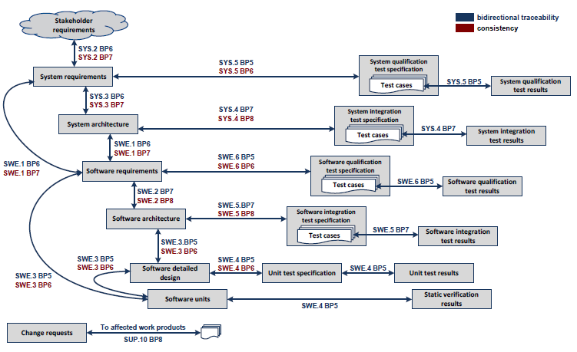
Figure 1 Bidirectional Traceability and Consistency of A-SPICE PAM 3.0

This project comply with A-SPICE test levels above.

The development schedule is composed of 9 releases, even though the goal is Release 7.
The duration of each iteration (release) would be as short as 3 months. Thus, Software Unit Verification should start and end at the same period of implementing. The basic testing of Software Integration is also done like SWUT. Then, 4 weeks are for testing the more specific Software Integration, Software Qualification, System Integration, and System Qualification, and 1 week for summarizing and reporting the test results.

Integration Strategy
Write a Software Integration Strategy.

Integration Test Strategy
Write a Strategy of Software Integration Testing.

Test Process
Write about Software Integration testing procedures.

The figure below depicts the testing overview of how to test.

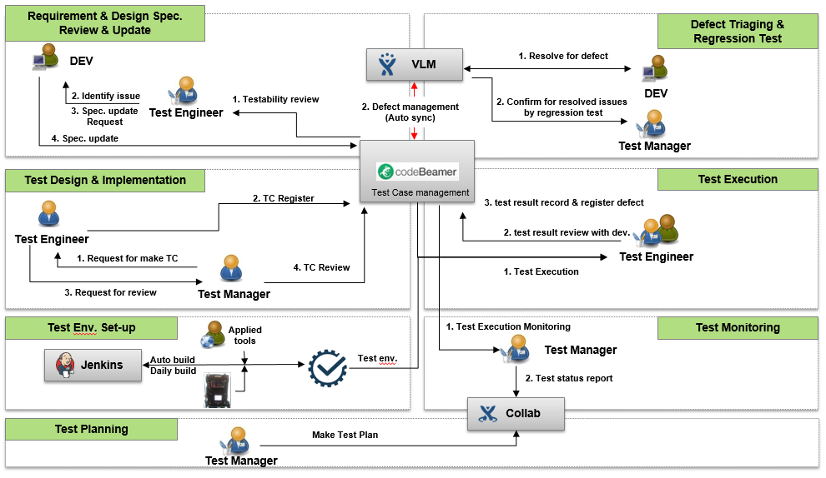
Figure 2 Test Process

Test Deliverables

Test Cases
Create a location of Test Case document for the Software Integration test.
http://val.lge.com/ivi/svn/DAI_MPC5_5/trunk/03_SW_Engineering/04_Test/03_SW_Integration_Test/02_SW_Integration_Test_Case

Test Results Report
Create a Software Integration Test Results Report Document Locations.
http://val.lge.com/ivi/svn/DAI_MPC5_5/trunk/03_SW_Engineering/04_Test/03_SW_Integration_Test/03_SW_Integration_Test_Report

Test Plan
Create a storage location for this document.
http://val.lge.com/ivi/svn/DAI_MPC5_5/trunk/03_SW_Engineering/04_Test/03_SW_Integration_Test/01_SW_Integration_Test_Plan

Reviews

Testability Review
Write the necessary processes, tools, and checklist for conducting a testability review.
Write the Review Technologies (Walkthrough / Technical Review ...) to be applied at the time of technical document review.
The figure below depicts the overview of revewing requirements testability.
Test Manager and tets engineers review the draft documents written by the development teams with the checklists.

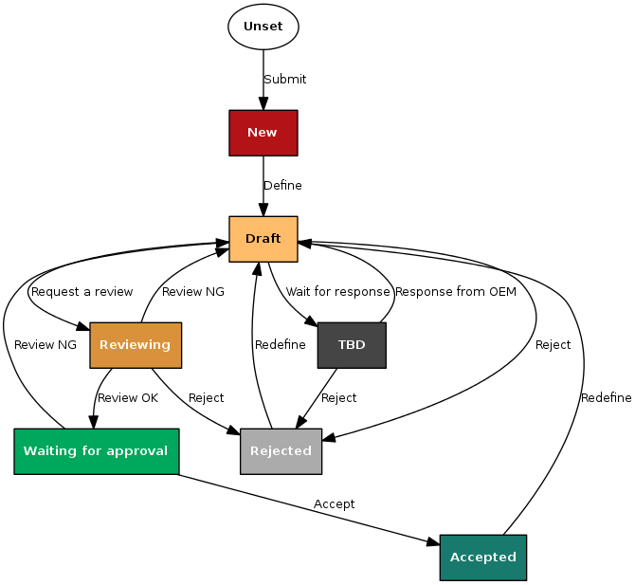
Figure 3 Requirement Testability Review

Test Case Verification Review
Create the necessary processes, tools, and checklists for the Test Case Verification Review.
Write a Review Techniques (Peer-review ...) to be applied when a Test Case Review.

Test Design Techniques

Interface Testing
Write a SW interface test plan.

Specification Based Testing
Write a method of performing specification-based tests.
Test Technique | Applicable (Y or N) | Remarks
Equivalence Partitioning
Boundary Value Analysis
Decision Table Testing
State Transition Testing
Combinatorial Testing
Scenario Testing
Test Techniques of Specification-Based Testing

Table 5 Test Techniques of Specification Based Testing
Test Technique | Applicable (Y or N) | Remarks
Equivalence Partitioning
Boundary Value Analysis
Decision Table Testing
State Transition Testing
Combinatorial Testing
Scenario Testing

Scenario Testing (example)

Structure Based Testing
Write a method of performing structure-based tests.

Test Technique | Applicable (Y or N) | Remarks
Statement Testing
Decision Testing
Branch Testing
Branch Condition Testing
(All) Path Testing
Control Flow Testing
Test Techniques of Structure-Based Testing

Table 6 Test Techniques of Structured Based Testing
Test Technique | Applicable (Y or N) | Remarks
Statement Testing
Decision Testing
Branch Testing
Branch Condition Testing
(All) Path Testing
Control Flow Testing

Experience Based Testing
Write a method of performing experiance-based tests.

Test Technique | Applicable (Y or N) | Remarks
Ad-hoc Testing
Exploratory Testing
Scripted Testing
Test Techniques of Experience-Based Testing

Table 7 Test Techniques of Structured Based Testing
Test Technique | Applicable (Y or N) | Remarks
Ad-hoc Testing
Exploratory Testing
Scripted Testing

Test Entry/Completion Criteria

Entry Criteria
Write the entry criteria for the Software Integration test.

Entry Criteria
Testability Review 및 Test Case Design Review 완료
Test Frame work 구축 완료
개발팀의 소프트웨어 Code Freeze
Completed SW Unit Test
Table 3-1 Entry Criteria

Completion Criteria
Write the completion criteria for the Software Integration test.

Table 8 Completion Criteria
Completion Criteria
R1 | R2 | R3 | R4 | R5 | R6 | R7
 |  | 30% | 50% | 70% | 90% | 100%

Metrics to be collected
See the Measurement Analysis Report in more detail (http://val.lge.com/ivi/svn/DAI_MPC5_5/trunk/02_Management/10_Quality_Measurement).

The Metrics of Measurement Analsysis
Write the measurement metircs for Software Integration test.

SW Interface Coverage (example)

Table 9 Metrics of Measurement Analysis
SW Interface Coverage
R1 | R2 | R3 | R4 | R5 | R6 | R7
 |  | 30% | 50% | 70% | 90% | 100%

The Metrics of Test Cases Develoment Plan
Write the software integration test test case preparation plan metrics.

Table 10 Metrics of Test Cases Develoment Plan
Test Cases Development Plan
R1 | R2 | R3 | R4 | R5 | R6 | R7
 |  | 30% | 50% | 70% | 90% | 100%

Retesting and Regression Testing
Write the Regression test cycle setting (e.g. Conducting a Regression Test after three retests) and retesting cycle setting.

Test Data
Write about Software Integration test data.

Table 11 Test Data
Test Data | Description
Test data for data flow | used for each sequence diagram is separately defined
Input/Output data of Componet v | Input Data  Output Data

Test Environment Requirements
Write about the Software Integration test environment.

Test Tools

SW Testing Tools
Write the SW tools used in the SW Integration test.

Table 12 Software Testing Tools
Item | Description | Remark
Interface Testing | OS: Linux 64bit  Tool : Gerrit | Ver 2.13.7
Specification Basd Testing | OS: Ubuntu 14.04.5 LTS / ARCH = x64  Compiler : GCC 4.8.1
Structure Based Testing | OS: Ubuntu 14.04.5 LTS / ARCH = x64  Compiler : GCC 4.8.1
Experience Based Testing | OS: Ubuntu 14.04.5 LTS / ARCH = x64  Compiler : GCC 4.8.1

Suspension and Resumption Criteria
Write about suspension and resumption criteria of the Software Integration test.

Table 13 Suspension/Resumption Criteria
Step | Criteria
Suspension | Cases that Source code and design output do not match or  Source code have an issue. And automation system finds build issues. (commit scores -1)  When critical defects or major defects occur such that there is a disruption in the overall test progress, the test manager should share the situation with the PL and major stakeholders and decide whether to stop the test by conducting a meeting to determine whether to discontinue the test.
Resumption | Cases that new patch-set with modified code. The test manager decides whether to resume the test through consultation with the relevant parties after the completion of the critical defect resolution.

Schedule
Write about the software integration test schedule
If the schedule has already been detailed in the Feature Release Plan or WBS, refer to the document.

Schedule for each activity can be changed flexibly according to progress. Refer to the WBS for detailed schedule for each changed schedule or activity. The WBS can be found on the SVN link below.

http://val.lge.com/ivi/svn/DAI_MPC5_5/trunk/02_ProjectManagement/03_WBS/LGE_[OEM]_MPC5.5_WBS_v1.0.mpp

The workflow of the process is as follows.

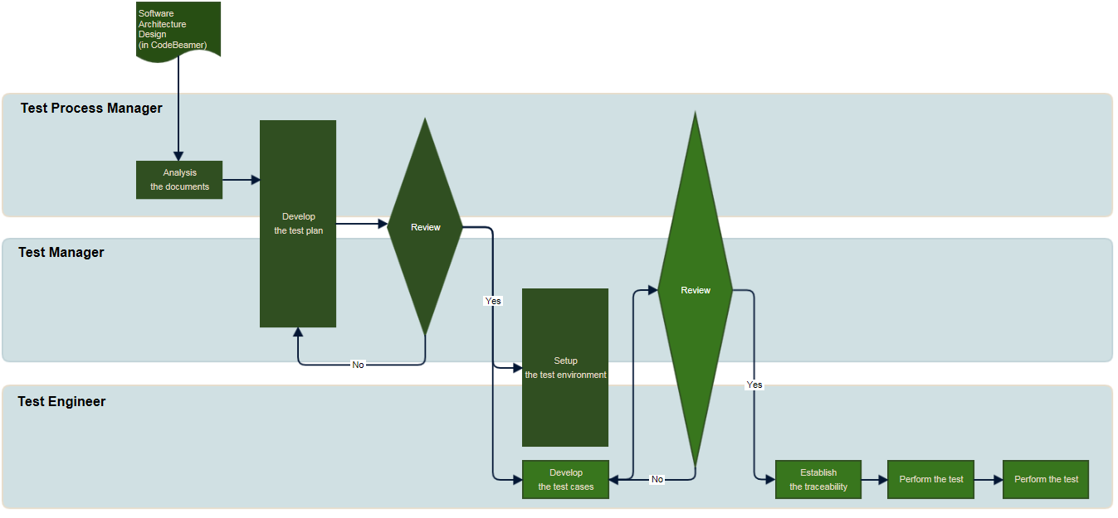
Figure 4 Workflow

Details can be found at the following address.
http://collab.lge.com/main/display/DAIMPC/SWE.5+Workflow

The SW Release Plan can be found at the following address.
http://val.lge.com/ivi/svn/DAI_MPC5_5/trunk/02_Project Management/00_Guide&milestone/02_Project Milestone/LGE_[OEM]_MPC5.5_SW_Release_Build_Plan_All_v1.0a.xlsx

